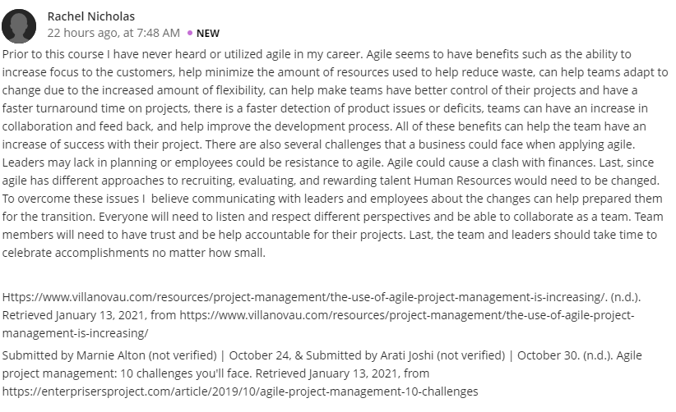
Hello Nicholas
Agile is a software development which is founded on frameworks like scrum, extreme programming and feature-driven development. The ultimate objective of its development is to render greater quality of services in a short period of time as well as offering predictability of future outcomes. This software turns in a handful of benefits. Firstly, the clients and seller relationship is improved since client satisfaction is guaranteed as a result of features that enable quick delivery of services therefore saving time. Secondly, the vendors are able to reduce wastage by concentrating on attributes that will yield more value to the product thus enhancing efficiency and retention of client base. Thirdly, the managers of consequent projects are able to plan more efficiently and effortlessly due to the features that enable them to focus on the tasks at hand and tracking the events of the operation as they unfold. Lastly, the teams involved in the development of the software and they tend to take pride seeing that their work is put into good use. For instance, scrum enables the team to reduce unproductive work and focus on what they like because they know that their work is valued by their clients.
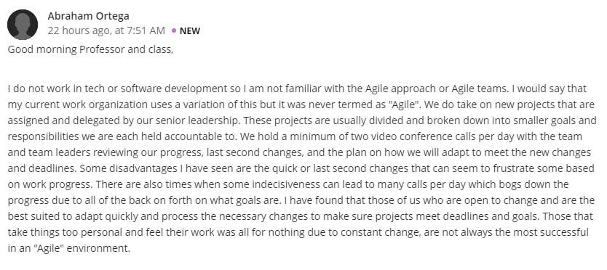
Hi Ortega
Agile project management is a relation concept used to oversee a project from when it begins to when it ends. It is a phenomenon that concentrates on maximum value delivery over other organizations operations as well as resource allocation. The principle involves scenarios where large projects are broken down so to ensure priorities are taken care of. In addition, Agile project run at regular fashion to make sure that clients are contented with the results. To add on that, Agile project management incorporates planning and implementation which enable the organization to cultivate an environment that encourages the team to take on responsibilities as required of them.

